Progress Report for Assignment 6

In our simulation, we will be shooting birds out of the sky while fireworks explode in the background. The classes we have are Bird, Particle, Firework, Lizard, Bug, and PaddleBall. The PaddleBall object will serve as a slingshot using spring code that will fling a ball towards the Birds while moving around the mouse. If a Bird gets hit by the ball on the PaddleBall, it will fall to the ground with gravity, bounce, and come to a stop with friction. Before it is hit, the Birds will move back and forth across the screen. The Fireworks are made up of many Particles and explode randomly in the background. The Lizard and Bug objects are randomly moving around in the background and bounce off the walls. If a Lizard runs into a Bug, the Bug disappears and is eaten.

Interactivity is involved when the user moves the mouse around to try and hit the bird. This program involves rules, particle simulation and physical simulation.

So far, each class has been created along with their main methods. However, the interactivity of each object has yet to be written.

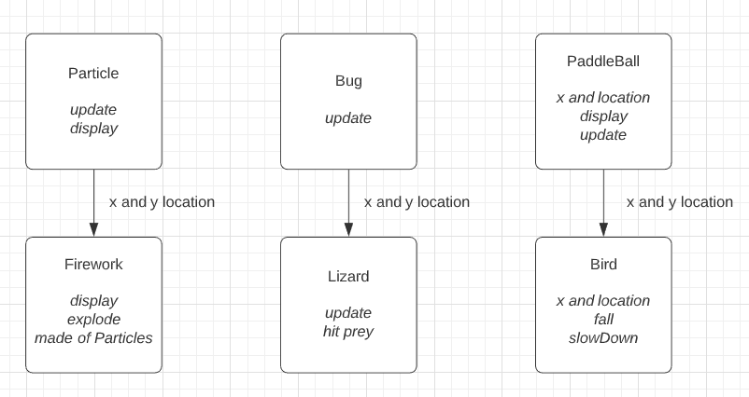

Declan – Bird class

Jenny – Particle and Firework classes

Jeff – PaddleBall, Lizard, Bug classes

